**BBSTT 15.10.1 Operating range: Start**

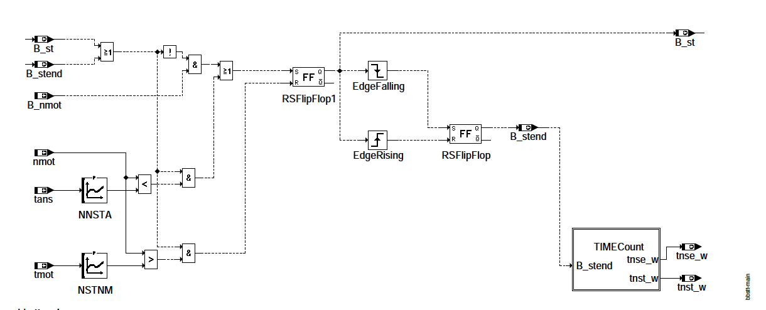

bbstt-main

Start condition B_st: - B_st is set if after KL15 On the start detection is completed and the motor is turning (! B_nmin).

- B_st is reset when the starting transmission speed NSTNM has been exceeded. The start condition is again when the speed drops below NNSTA.

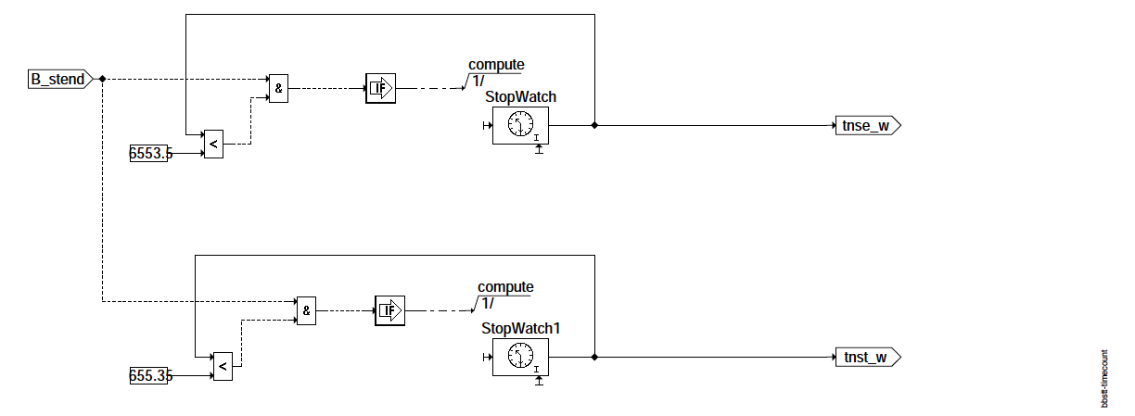

**bbstt-timecount**

Time after start tnst_w: With the start end, the post start time tnst_w is started. If the maximum value of tnst_w has been reached, tnst_w is limited to this (dito tnse_w).

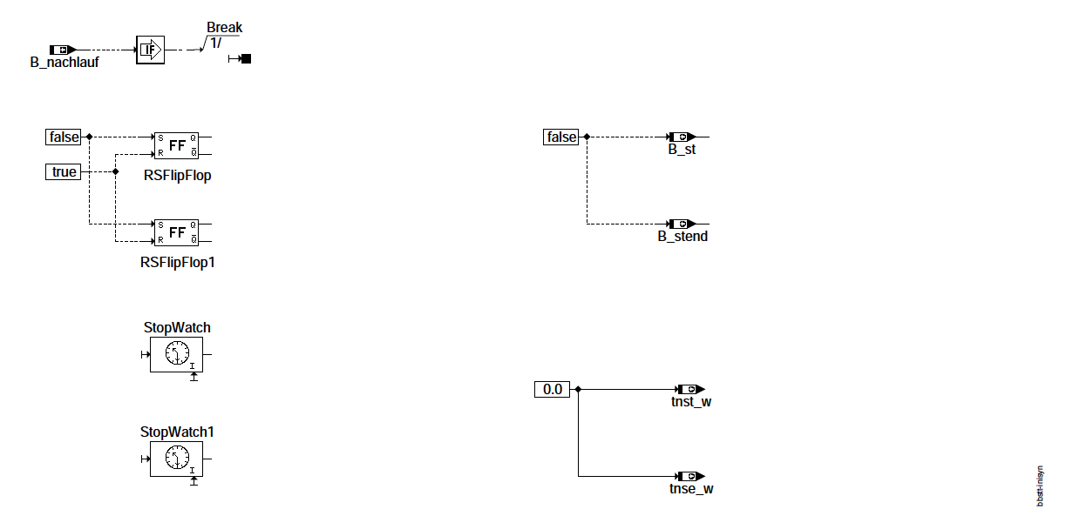

**bbstt-inisyn**

If the tracking is active, the values are not initialized

**ABK BBSTT 15.10.1 Abbreviations**

|  |  |  |  |  |
| --- | --- | --- | --- | --- |
| **Parameter** | **Source-X** | **Source-Y** | **Type** | **Name** |
| NNSTA | TANS |  | KL | Speed Normal -> Start |
| NSTNM | TMOT |  | KL | transition Start -> Normal |
| **Variable** | **Source** | **Referenced by** | **Type** | **Description** |
| B_NACHLAUF | BBSYSCON | BBSTT,  BGWNE, HT2KTPH, -  HT2KTWNE, T2STRL | ON | control SG caster |
| B_NMOT | BGWNE | ADVE, AEKP, ALE, -  ALSU, BAKH, ... | ON | condition engine speed: n> NMIN |
| B_ST | BBSTT | AAGRDC, ADVE, -  ALBK, BGPIRG, -  BGTOL, ... | OFF | condition start |
| B_STEND | BBSTT | ADAGRLS, ADVE, -  AEKP, ALE, AMSV, ... | OFF | condition starting reached |
| NMOT | BGNMOT | AAGRDC, ADAGRLS, -  ADVE, ALBK, AMSV, ... | ON | engine speed |
| TANS | GGTFA | ADAGRLS, ADVE, -  ATEV, ATR, BBKH, ... | ON | intake air temperature |
| TMOT | GGTFM | ADAGRLS, ADVE, ALE,  ARMD, AWEA, ... | ON | motor temperature |
| TNSE_W | BBSTT | BAKH, BBAGR, BBKW,  BDEMKO, BGAGR, ... | OFF | timers from the end of the start (16bit) |
| TNST_W | BBSTT | ABKVP, BBDNWS, -  BBKH, BBNWS, -  BBSAWE, ... | OFF | Time after start |

**FB BBSTT 15.10.1 Function description**

1. Transition from Initialization to Start: Sequence Startup (Overview):

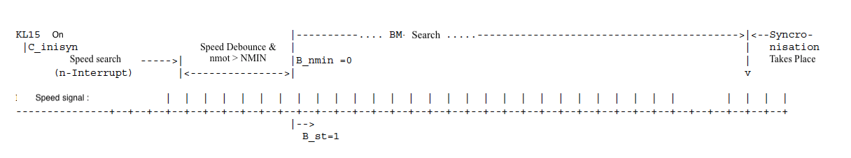

After initialization, the tooth interrupt is released and waited for the first speed signal. With the first speed signal the speed debounce is started. After deceleration and exceeding a minimum speed the condition !B_nmin (motor turns) and thus also B_st is set.

2. Transition from start to post start:

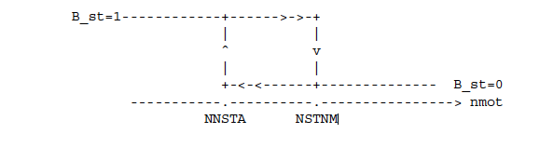

APP BBSTT 15.10.1 Application Notes

